*Programmer Test 2*

***1.1***

*function first($size)*

*{*

*for($i = 0; $i <= $size; $i++)*

*{*

*for($j = 0; $j <= $size - $i; $j++)*

*echo " ";*

*for($k = 0; $k <= $i; $k++)*

*echo 'O';*

*echo "\n";*

*}*

*}*

***1.2***

*function second($size)*

*{*

*for($i = 0; $i <= $size; $i++)*

*{*

*for($j = 0; $j <= $size - $i; $j++)*

*echo " ";*

*for($k = 0; $k <= $i; $k++)*

*echo 'O';*

*for($l = 0; $l <= $i - 1; $l++)*

*echo 'O';*

*echo "\n";*

*}*

*}*

***2.1***

*$salary = 10200*

***2.2.1***

*200*

***2.2.2***

*Your Score is: Average*

***3.1***

*15000, 20000*

***3.2.1***

*echo $marks["mohammad"]["physics"];*

***3.2.2***

*foreach($marks as $mars)*

*{*

*foreach($mars as $subs)*

*echo $subs . " ";*

*}*

***4.***

*<style>*

*div*

*{*

*float:left;*

*width:240px;*

*height:200px;*

*margin-left:10px;*

*border:1px solid black;*

*}*

*</style>*

*<div>1</div>*

*<div>2</div>*

*<div>3</div>*

***5.1***

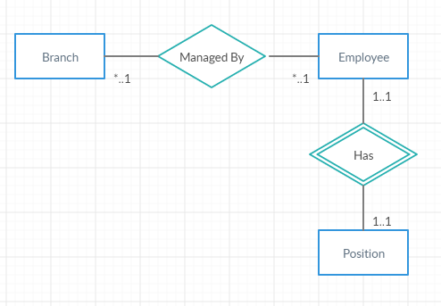

***5.2***

# INSERT INTO Branch

VALUES(name = ‘New Branch’)

WHERE province = “เชียงใหม่” OR

Province = “เชียงราย” OR

Province = “ภูเก็ต”;

***5.3***

DELETE FROM position

WHERE position_name = “sale”;

***5.4***

UPDATE Branch

SET branch_name = “นราธิวาส”

WHERE branch_name = “ปัตตานี”;

***5.5***

SELECT * FROM Employee LIMIT 0, 400;

***5.6***

SELECT * FROM Employee

LEFT JOIN Branch ON Employee.branch_id = Branch_branch_id

WHERE Branch.branch_name = ”ระยอง” AND Branch.branch_name “กรุงเทพ”;

***5.7***

SELECT * FROM Employee

LEFT JOIN Branch ON Employee.branch_id = Branch.branch_id

LEFT JOIN Position ON Employee.position_id = Position.position_id

WHERE Branch.branch_name = “เลย” AND Position.position_name = “programmer”;

***5.8***

SELECT * FROM Employee

LEFT JOIN Branch ON Employee.branch_id = Branch.branch_id

LEFT JOIN Position ON Employee.position_id = Position.position_id

ORDER BY Employee.employee_id ASC;

***6.***

Well Paid Job

***7.***

Google, Stack Overflow, YouTube, etc..

***8.***

Model, View, Controller

Model = Manages the Database

View = Return the requested page to the clients

Controller = Control the user input data

M

V C

***9.***

FTP on steroid. (The world's leading software development platform)

<https://github.com/>

***10.***

<https://en.wikipedia.org/wiki/Docker_(software)>

***11.***

A Dependency Manager for PHP

<https://getcomposer.org/>

***12.***

Prepros compiles your files, transpiles your JavaScript, reloads your browsers and makes it really easy to develop & test your websites so you can focus on making them perfect.

<https://prepros.io/>

***13.***

0

***14.***

Never

***15.***

Codeigniter – someone told me to

***16.***

Google fancy Web Service

***17.***

Make your websites become easier to find.